Health Check
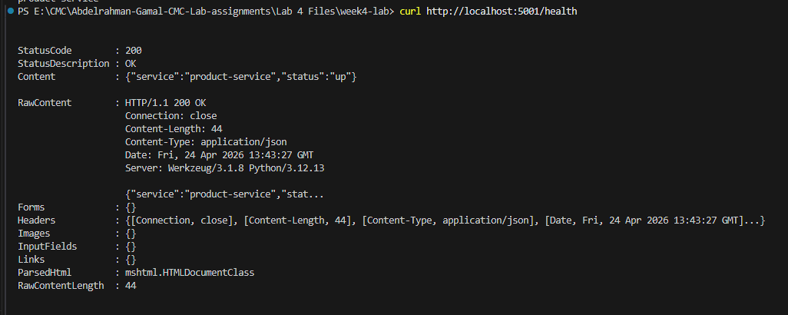

Product Check
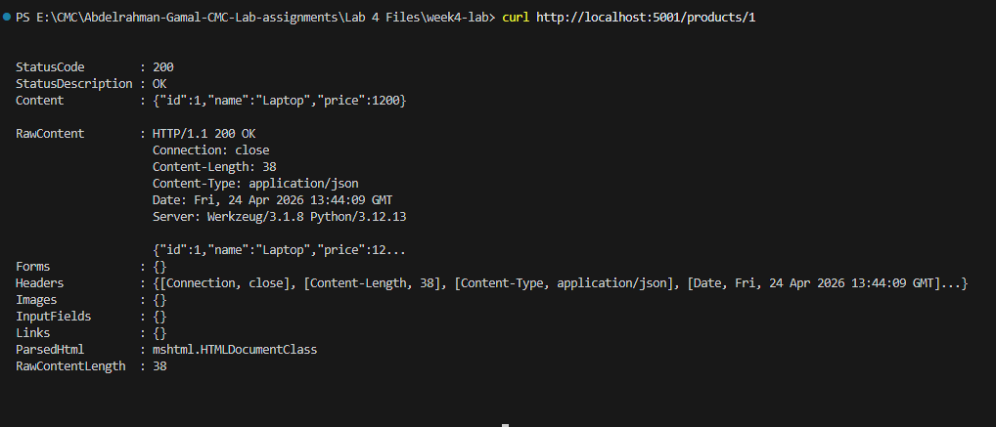

Testing order-service:
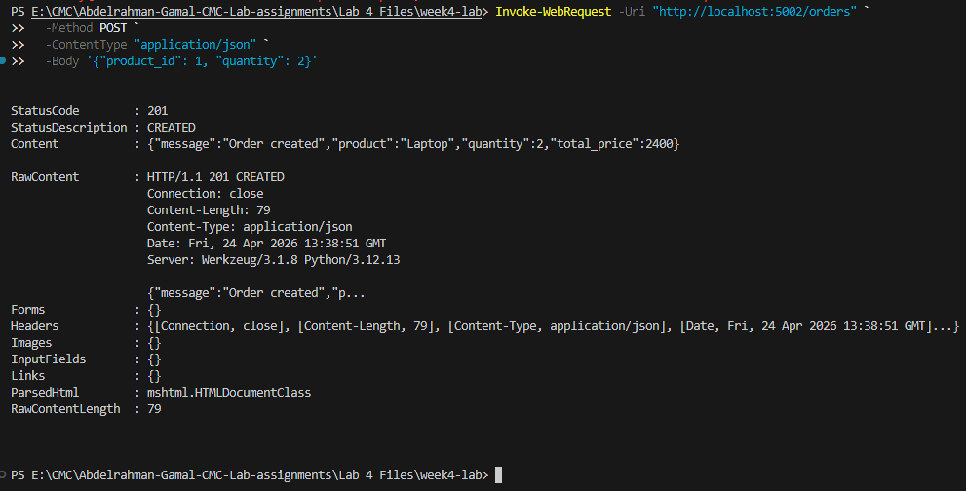
Testing Failure:
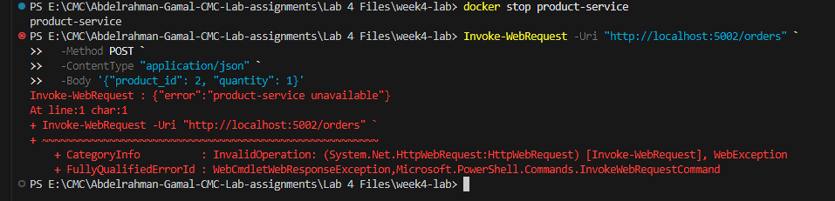
1. Which parts of this lab show the benefits of microservices over a monolith?
- Independent Failures: If product-service crashes, order-service stays running (fault isolation).
- Separation of Concerns: Each service has a single responsibility (managing products vs. managing orders).
- Independent Deployments: You can update and deploy one service's container without affecting the other.

2. Which new complexities were introduced by splitting the system into two services?
- Network Overhead: Services must communicate over HTTP instead of fast local function calls.
- Failure Handling: order-service requires complex logic (timeouts, retries, error handling) for unreliable network calls.
- Configuration & Orchestration: You must manage environment variables (PRODUCT_SERVICE_URL) and use tools like Docker Compose to run multiple containers together.
3. What would break if network latency increased or one service became slow?
- Timeouts: The 2-second timeout in requests.get will cause orders to fail immediately if the network is slow.
- Retry Storms: The retry logic (retries=2) will multiply requests to a struggling product-service, potentially crashing it entirely.

